**LAMBDA FUNCTION TRIGGERING USING CLOUD WATCH EVENT**

TO CREATE AN INFRASTRUCTURE USING A CLOUD FORMATION TEMPLATE, DELETE UNUSED VOLUMES AND SNAPSHOTS, AND TRIGGER THE LAMBDA FUNCTION USING CLOUD EVENT BRIDGE.

**STEPS:**

* Create an EC2 instance, with EBS volume and Snapshot using Cloud Formation Template in JSON.
* Delete EC2 manually; this will be monitored by the Drift Detect status in Cloud Formation. After the instance is deleted the EBS volume will be in available status and it not be attached to any instance, those volumes are called stale resources.
* Write a Lambda Python code for cost optimization to find and delete unused volumes and snapshots (stale resources).
* Trigger the lambda function using Cloud Event Bridge.

**STALE RESOURCES**

Stale resources in AWS refer to unused, underutilized, or forgotten cloud resources that are still incurring costs or consuming resources without providing value. These resources can lead to inefficiencies and increased cloud spending. Identifying and cleaning up stale resources is essential for maintaining a cost-effective and well-managed AWS environment.

**Examples of Stale Resources:**

1. **Unused EC2 Instances**:
   * Stopped instances that are not terminated.
   * Running instances that are idle (low CPU, network, or I/O utilization).
2. **Unused EBS Volumes**:
   * Detached EBS volumes not associated with any EC2 instance.
   * Snapshots of unused volumes that are not needed for backup purposes.
3. **Unassociated Elastic IPs**:
   * Elastic IP addresses allocated but not attached to any instance.
4. **Old Load Balancers**:
   * Load balancers with no registered instances or minimal traffic.
5. **Unused S3 Buckets**:
   * Empty or infrequently accessed buckets that might not be serving any purpose.

**Automating Clean up:**

To automate the removal of stale resources, you can:

* Use AWS Lambda functions triggered by AWS Config rules or CloudWatch Events.
* Implement scheduled jobs using AWS Systems Manager or custom scripts.

Created an EC2 instance with EBS volume using CFT,

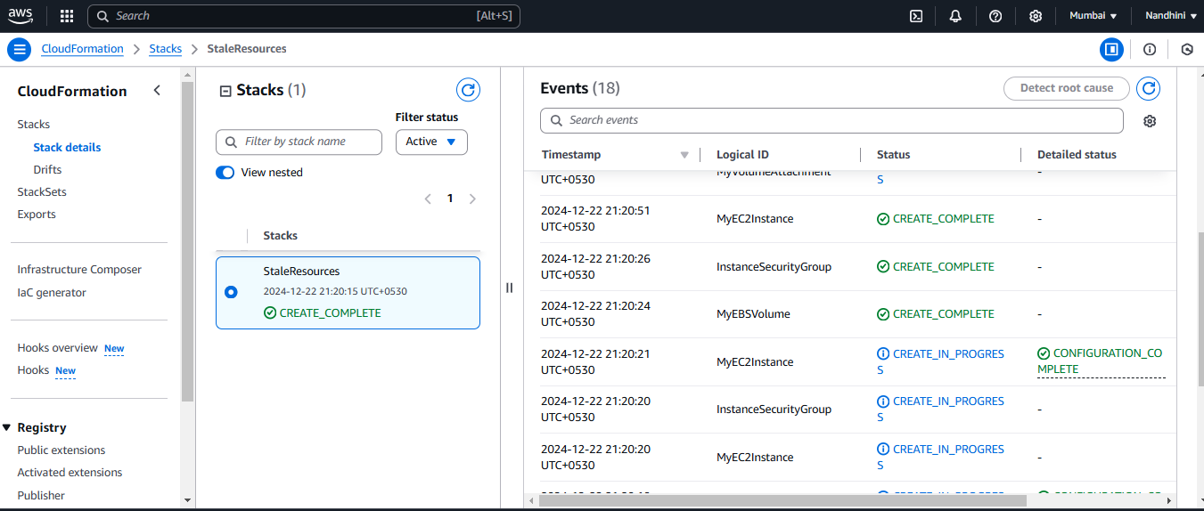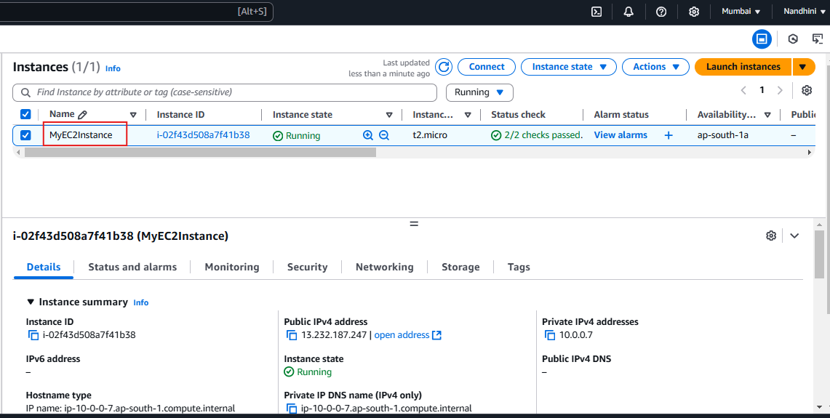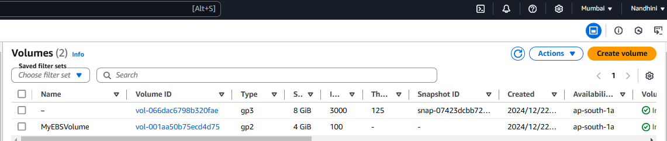

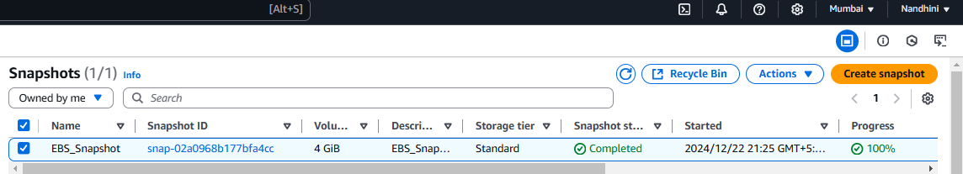

EC2 instance stopped and terminated manually, to monitor the drift detect status in Cloud Formation.

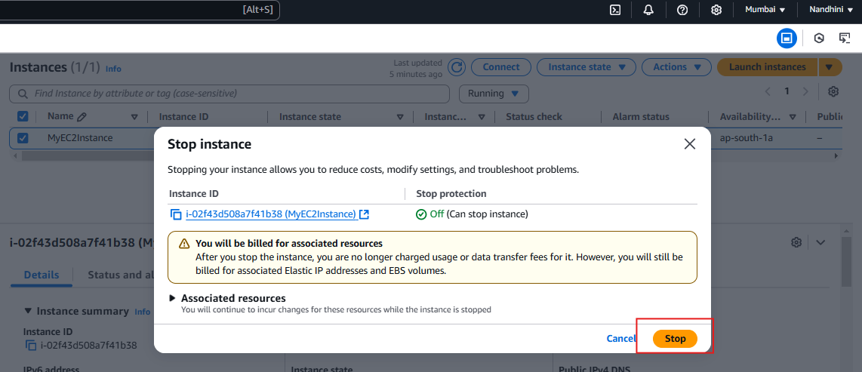

Once the instance get terminated its root volume also will get deleted. EBS volume will be in available since it is not attached with any instances.

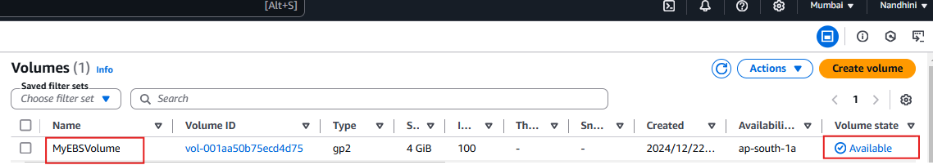

Drift Detect status:

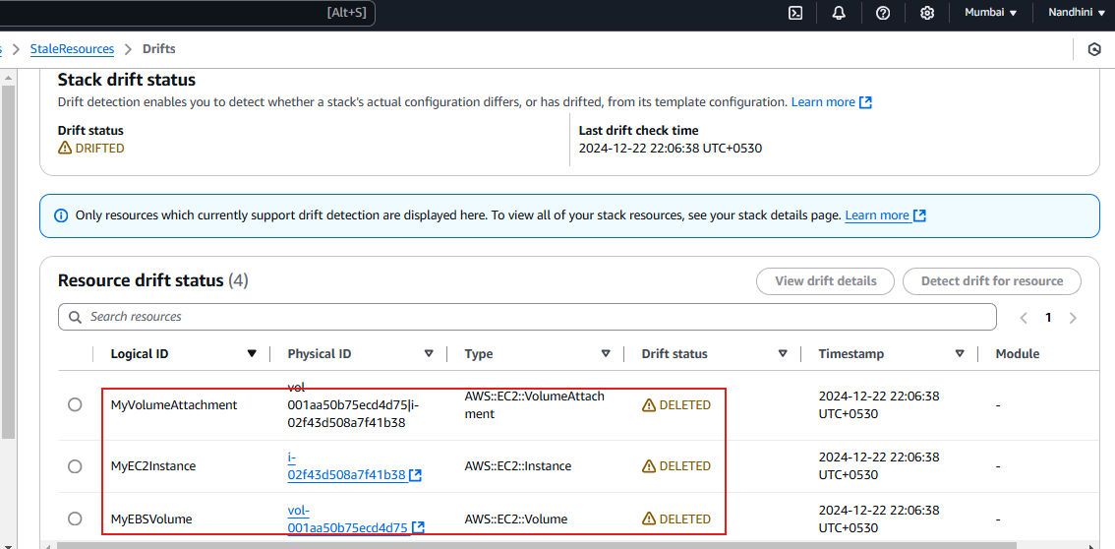

Create Lambda function to deploy Python code to find and delete unused Volume and Snapshot.

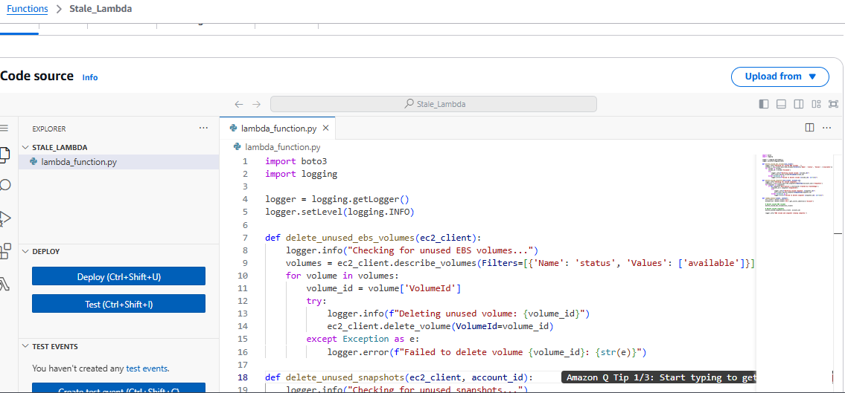

Rule created to trigger lambda function using event bridge,

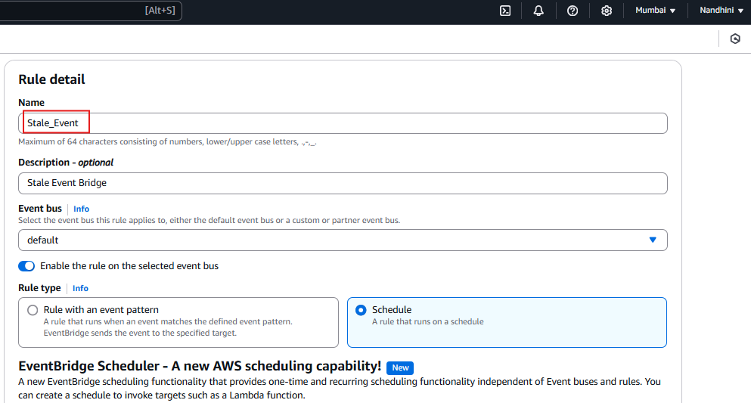

Event Bridge schedule:

Used Cron job to trigger lambda function using syntax.

Cron (MINUTE HOURS DOM MONTH DOW YEAR)

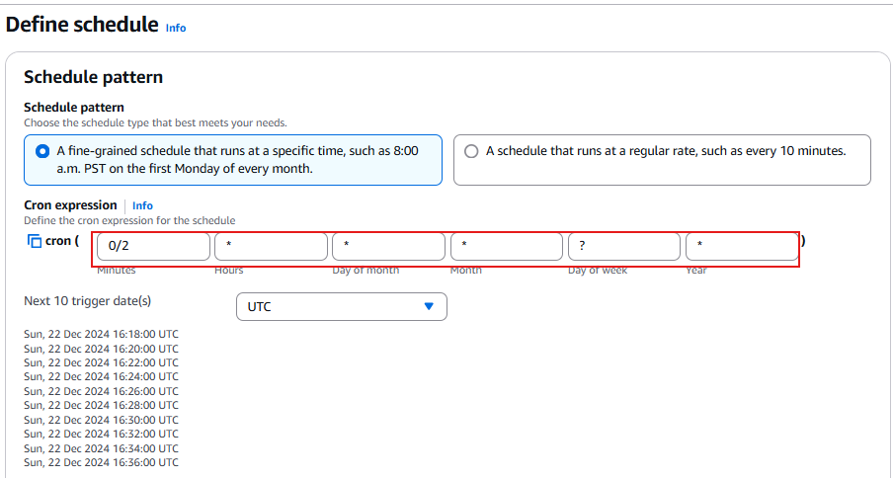

Once the lambda function got triggered, Cloud log will shows the output.

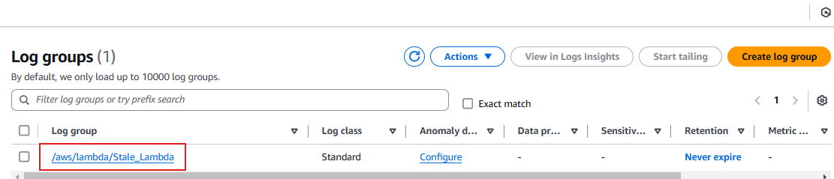

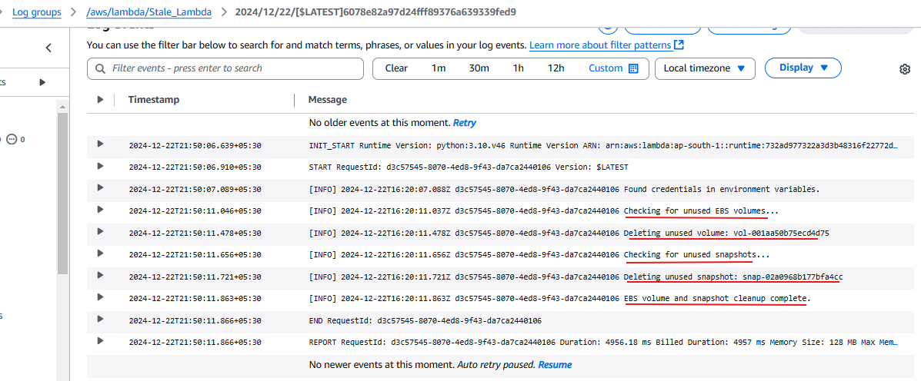

Unused volumes and snapshots got deleted.

